2 Creating the Project

Table of Contents

To turn back on your Watch SASS 1

Starting the Project 1

Emmet Short cut for creating HTML Boiler Plate code 1

The link for the Style Sheet 1

Setting up the folder and files for the SCSS 1

The CSS Folder Automatic Generation 1

Testing our SCSS file 1



# To turn back on your Watch SASS

You might have to go back to settings, put SASS in the search bar, and go to the wheel here

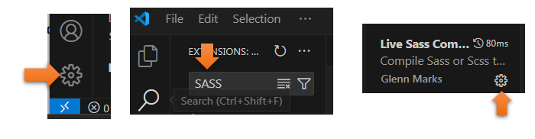

At the bottom, choose WATCH SASS

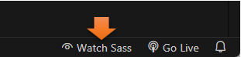

# Starting the Project

You want to start by opening Visual Studio Code



Create a new folder

You will want to create a new folder for your SASS project somewhere on your computer, or you could just hover and create the new folder right inside of Visual Studio code

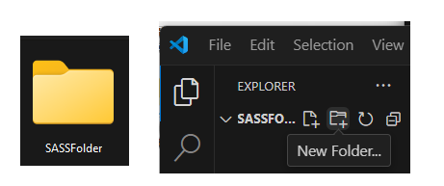

Then open it, you want to create a dist folder, and an index.html file, inside of that. Hovering right here in the Visual Studio, will allow you to see the icons, where you can select to create both a new folder, and a new html file.

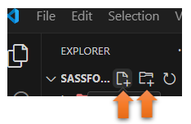

Watch it, Notice that we are placing the index.html inside of the dist folder, you know it is inside because it is indented from the dist folder.

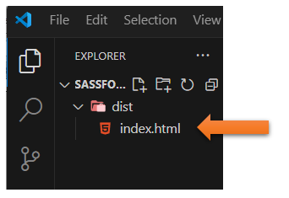

# Emmet Short cut for creating HTML Boiler Plate code

Shift-exclamation-Enter will give you the boiler plate code

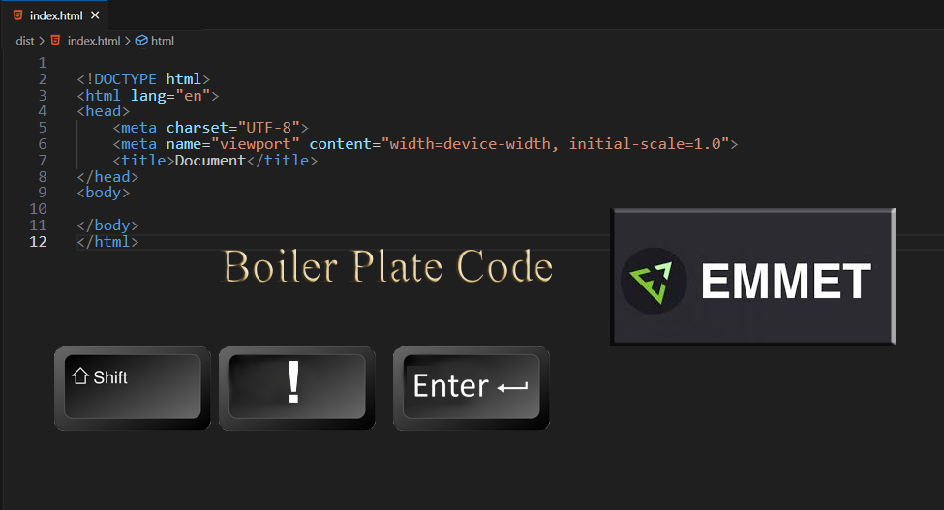

We can just name the project **SASS**

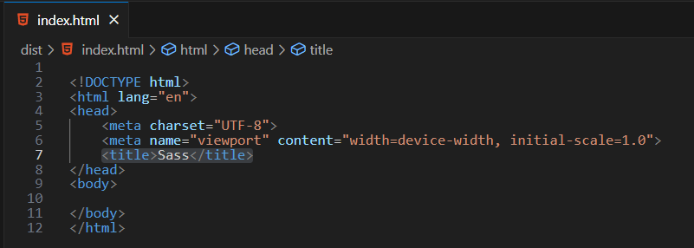

# The link for the Style Sheet

Watch it, Ok, now this is important! Because when we are linking to the style sheet from our HTML file, we DO NOT use **SASS** or **SCSS**, which is another name for this. Since browsers do not understand this technology, it must be turned back into regular CSS before it can be processed by the browser.

We have not yet made our style sheet yet, but this is what the link will look like

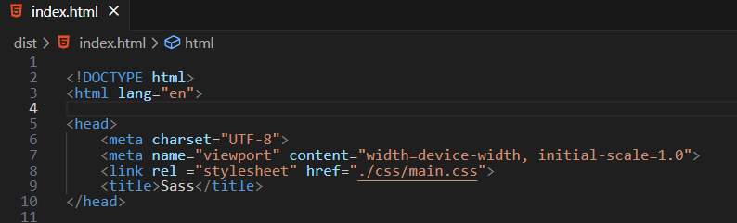

SCSS is the newer version of SASS, as it does not use the more difficult syntax form which entails braces and semi-colons. For this tutorial, we will be dealing with the easier version of SCSS, but it is all just as Sassy to me.

Note- Make sure you add this line to make this connection to your style sheet

<link rel ="stylesheet" href=".\css\main.css">

# Setting up the folder and files for the SCSS

This time, make sure that you are outside of the dist folder, we will be setting up this folder in the root of folder.

Check the indent of the new folder, it should be at the same level as the dist folder and not indented.

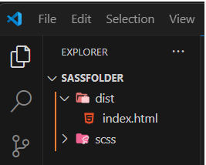

Inside of that new folder, create the **main.scss** file. Your file folders and file indents should now look like this.

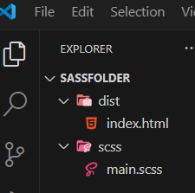

Open that main.scss file in Visual Studio

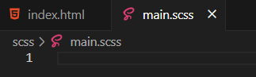

Look at the bottom task bar, it should be saying watch Sass if the extension for Sass was installed correctly.

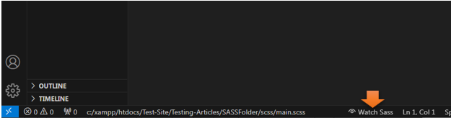

Now if you click on the taskbar that says **Watch Sass**, you will see an output in the **terminal** pop up.

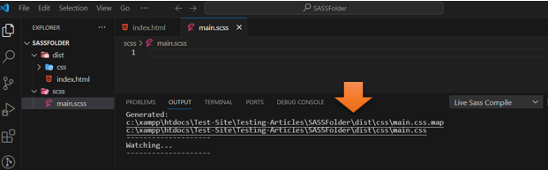

# The CSS Folder Automatic Generation

Since you clicked on that Watch Sass button at the bottom, it has automatically created a CSS folder for you. You did not create this folder. It is automatically generated for you when you hit that SASS button.

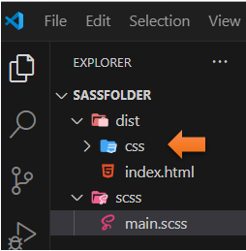

If you open up that folder, you will see two files, that were also automatically generated for you.

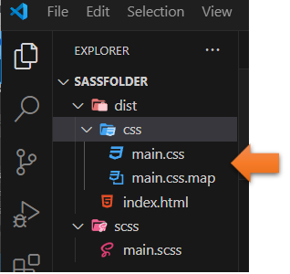

# Testing our SCSS file

Make sure you are in your scss file and not any other file. Remember things start out here and then it is recognized by the Watch Sass, and turned into CSS.

Here we will just test some simple CSS, since we know that SCSS also recognizes CSS.

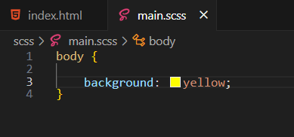

Watch it, Make sure you save for things to work

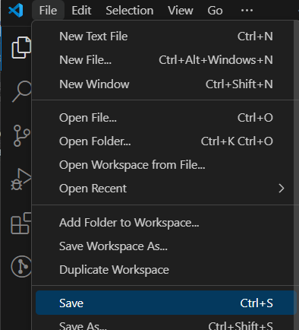

Now go and look at your CSS file, because as soon as you saved the SASS compiler automatically wrote your code into the CSS file.

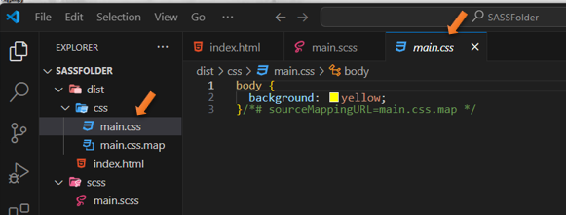

If you have **Live Server** installed inside of your Visual Studio Code, you can hit that and view what you did inside of a browser

Watch it, make sure before you hit your live server, you are on your **index.html** file, or you will just be seeing some weird files.



Yeah, that is some bright sunshine on a webpage there.



Watch it, when using SCSS, **never modify the CSS file**, you only want to modify the SCSS file, and have that write all of your CSS code for you.